Variables

Variable is the name of a memory location which stores some data.

Memory

a

b

S

25

Variables

Rules

1. Variables are case sensitive
2. 1st character is alphabet or '_'
3. no comma/blank space
4. No other symbol other than '_'

Variables

Data Types

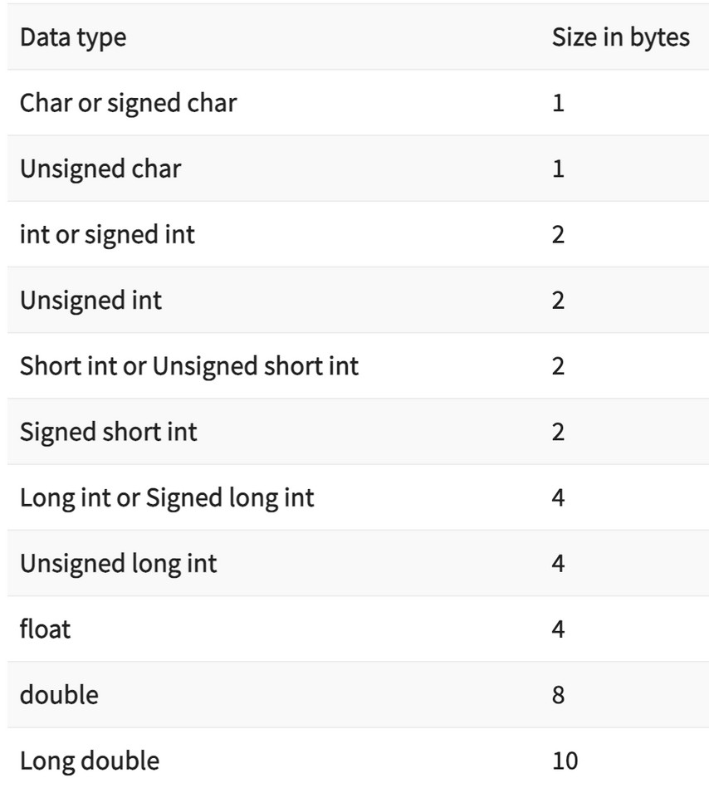

Constants

Values that don't change(fixed)

Types

Integer

Constants

1, 2, 3, 0

Real Constants

Character

Constants

'a', 'b', 'A',

, -1, -2 1.0, 2.0,

3.14, -24

'#', '&'

Keywords

Reserved words that have special meaning to the compiler

32 Keywords in C

Keywords

|  |  |  |  |
| --- | --- | --- | --- |
| auto | double | int | struct |
| break | else | long | switch |
| case | enum | register | typedef |
| char | extern | return | union |
| continue | for | signed | void |
| do | if | static | while |
| default | goto | sizeof | volatile |
| const | float | short | unsigned |

Program Structure

*#include<stdio.h> int main() {*

*printf("Hello World");*

*return 0;*

*}*

Comments

Lines that are not part of program

Single Line Multiple Line

/*

//

*/

Output

printf(" Hello World ");

new line

printf(" kuch bhi \n");

Output

CASES

1. integers

printf(" age is %d ", age);

1. real numbers

printf(" value of pi is %f ", pi);

1. characters

printf(" star looks like this %c ", star);

Input

scanf(" %d ", &age);

Compilation

A computer program that translates C code into machine code



Hello.c C Compiler

a.exe (windows)

a.out (linux & mac)